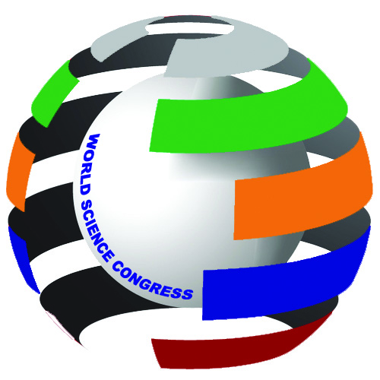
WORLD SCIENCE CONGRESS
Inspiring Science

58/24, Prince Anwar Shah Road, Lake Gardens, Kolkata – 700 045, India
Email : worldsciencecongress@gmail.com
Web : www.worldsciencecongress.com
Cell : +91-8961003137/9038464694/9038692617

10.8.2016
To
The Hon’ble Rector
Tomsk State University Russia
Russia, 634050, Tomsk, pr. Lenina, 36
rector@tsu.ru

Sir,
The World Science Congress, the Incredible International Science Association, will host its 3rd National Sustainable Environment Conference in PGIMER auditorium of Dr. RML Hospital, New Delhi on 23rd &24th December 2016 (Friday & Saturday).
The theme Topic of the Conference is ‘Save Environment, Save Life, Save World’. Registration detail will be uploaded in website.
You may send your paper/abstract by October 2016.
Please confirm your participation by October 2016.
Thanking you.
Sincerely,


Prof. Col. Dr. Ranajit Sen
FDS RCS(Edin), PGTOS(London), DOS(Leiden), Ph.D., LL.B.
Chairman
World Science Congress

